**SCREEN SHOTS**

**Course-end Project 1**

**Implement Azure IaaS**

Step 1 : Create virtual networks in the East US region

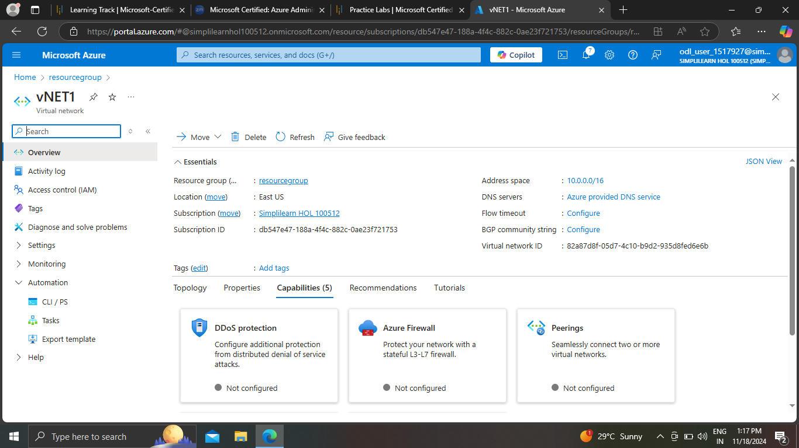

Step 1 : Create virtual networks in the Central India region

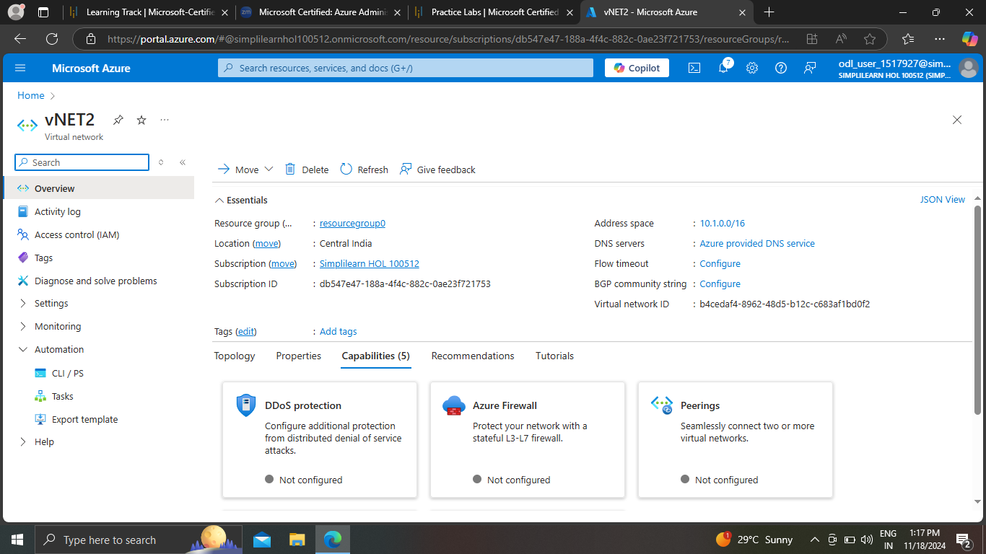

Step 2: Create test virtual machines in both the virtual networks

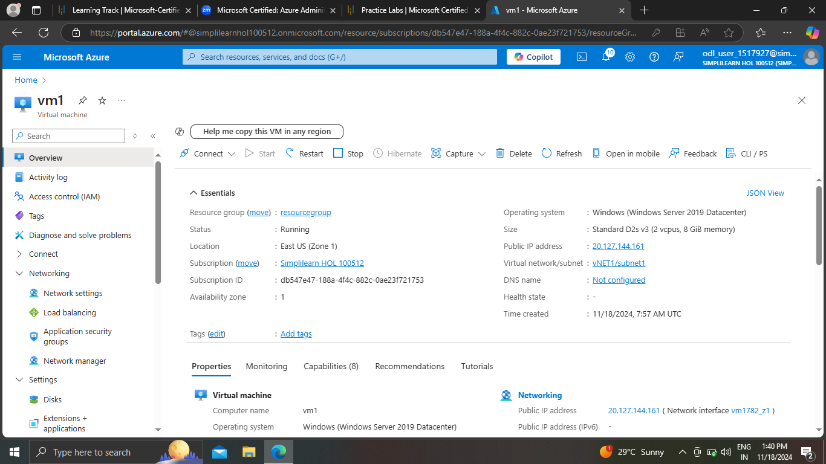

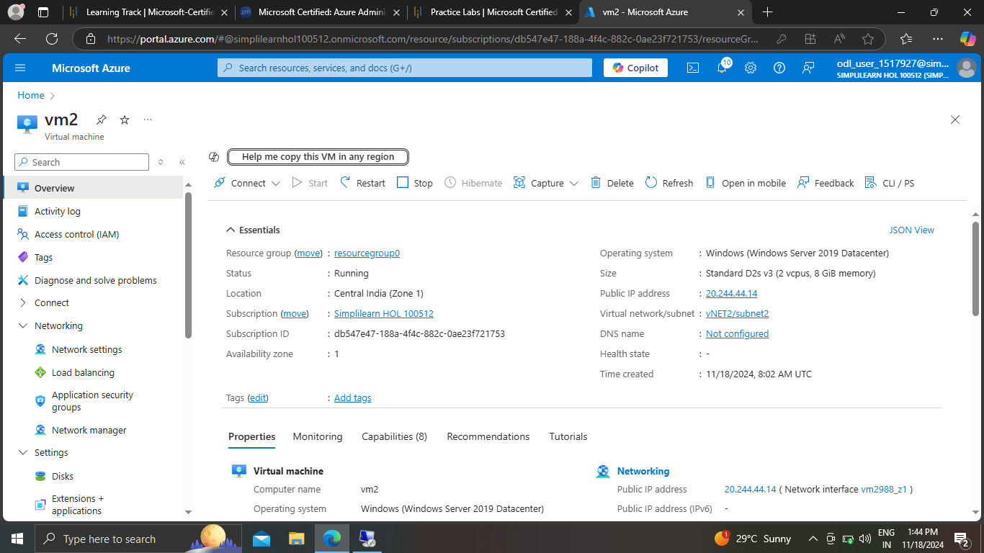

Step 3: Establish the connectivity between both the networks via VNet peering

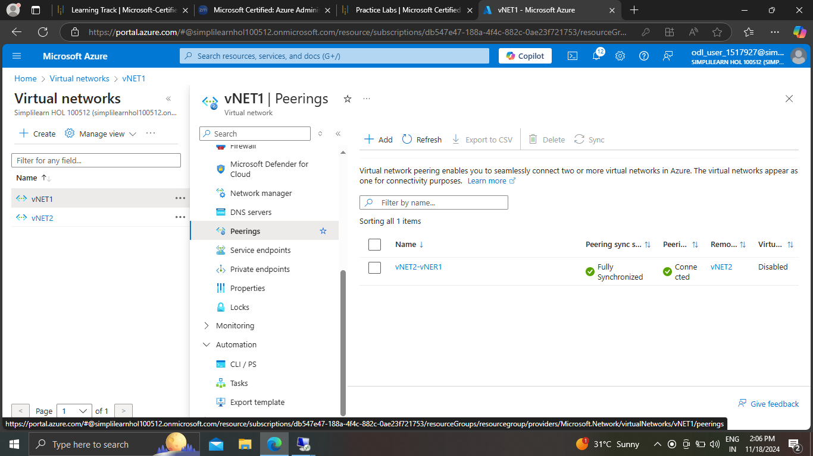  
Step 4: Ensure connectivity is established properly

